Title of abstract in Arial font: size14 point, centered paragraph

○ Author FAMILY^{1*}, Second-author WATER¹ & Third-author ENVIRONMENT²
¹Department of Environmental Engineering, Environmental University, Miyagi 980-8579, Japan.
²Department of Water Environment, Engineering University, Miyagi 980-8579, Japan.
*E-mail: e-mail address of the lead presenter.

Abstract

This is the instruction and sample of the abstract for the International Symposium on Water Environment Systems. The article length is limited within two pages. Set the margins to 2.19 cm above, 3 cm below, 2.25 cm to the left, and 1.75 cm to the right. Use bold Arial font 14 points for Title and Times New Roman font in the author information, 12 points for the Authors and 10.5 points for the Affiliations. The E-mail address of the lead presenter should be informed. Use Times New Roman font 10.5 points for the abstract and Keywords, 9.5 points for the main text including Introduction, Materials and Methods, Results and Discussion, Conclusions, Acknowledges, References and Tables. Use at least 0 pt spacing in the main text. You can insert figures if needed while the content may be print in black and white. Use bold Times New Roman font 9.5 points for the figure captions and table titles. Please ensure that every reference cited in the text is also present in the reference list and vice versa. Indicate references by numbers in square brackets [] in line with the text. This template can be used directly with adding you own content.
Keywords: keywords 1; keywords 2; keywords 3; keywords 4; keywords 5.

1 Introduction
This part is Introduction.

2 Materials and methods
This part is Materials and methods.

3 Results and discussion
This part is Results and discussion.

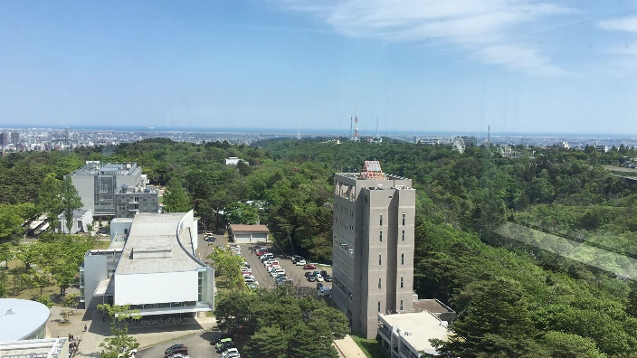
Fig. 1. This is a figure sample.

Table 1 This is a table sample.
Items | Content 1 | Content 2
1 | A | B
2 | C | D
3 | E | F

4 Conclusions
This part is Conclusions.

Reference
[1] Authors, title, journal name, issue (year) begin page-end page.

