Forest fire severity estimation for the 2017 Kamaishi forest fire

○Grace Puyang Emang1*, Yoshiya Touge 1, So Kazama1
1Graduate School of Engineering, Tohoku University, Sendai 980-8579, Japan

*E-mail: grace.puyang.emang.r2@dc.tohoku.ac.jp

Abstract
The 2017 Kamaishi forest fire occurred for 14 days from 8th till 22nd May 2017 and the total burnt area was 413 ha which is greater than the total burnt area for the whole Japan in 2016. This burnt area was estimated based on burnt and unburned area. However, in the burnt area itself, there were differences of fire severity observed. The objective of this research was to estimate the fire severity in this burnt area using Normalized Difference Vegetation Index (NDVI) and post fire observations of stem-bark char height,${ h}_{c}$ and crown scorch height, $h_{s}$. The results shows that NDVI and $h_{s}$ has stronger relationship than $h_{c}$ suggesting both are sensitive towards fire severity on leaves while $h_{c}$ is related to fire severity on stem-bark.

Keywords: Fire severity, NDVI, Post-fire observations, Kamaishi

1. Introduction
Forest fire occurs annually in developed and developing countries. Between 2010 till 2014, forest and field fire are reported annually with an average of 1635 cases and an average annual loss at approximately 576 million yen (Statistic Bureau Japan, 2018). Forest fire causes not only economic loss but also losses of animals’ habitat and food resources.
Ecosystem of the forest is also affected based on fire severity as increased in sedimentation yield and concentration was observed in burned watershed in Oldman River Basin, Alberta (Silins et al., 2009) and in Colorado Front Range, higher sedimentation production rate was found in high severity forest fire than moderate and low severity forest fire (Benavides-Solorio and MacDonald, 2005). Most research focused on estimation of burnt area and hotspots using remote sensing data such as NDVI (Kasischke and French, 1995) but in burnt area, various degree of fire severity exist and can be seen from loss of vegetation.
Fire severity is used to measure the loss or change of the above and below ground organic matter (Keeley, 2009) such as char height and scorch crown height. This research will use NDVI and char height on stem- bark, $h_{c}$ and height of scorch on crown, $h_{s}$ to estimate the fire severity in the 2017 Kamaishi Forest Fire.

2. Study area
In the last 42 years, Kamaishi had three major fire incidents with burnt area of 200 ha, 392 ha and 130 ha in Kamaishi Hamacho, Kamaishi Higashimae-cho and Kamaishi Toni-cho respectively and recently, in Kamaishi Heita with an estimated burnt area of 413 ha (Touge et al., 2018), the study area for this research as shown in Fig. 1. This indicates that Kamaishi is prone to forest fire and burnt areas were wide.

Fig.1 Historical large scale forest fire occurring in Kamaishi

3. Methodology
3.1 Remote sensing data
NDVI which were cloud free from Landsat 8 were used in this research for the period of 2017. These images were then processed to create a two weeks average in an image and subsequently, ${NDVI}_{\begin{aligned}diff \\ \end{aligned}}$ were computed by subtracting the post-fire image from the pre-fire image.

3.2 Post-fire observation: stem-bark char height, $h_{c}$ and scorch crown height, $h_{s}$
Two types of post-fire observations were made, namely stem-back char height, $h_{c}$ and scorch crown height, $h_{s}$. For every 30 m, a tree was observed of its fire severity by measuring the char height on its stem bark, $h_{c}$ and the scorch height on its crown, $h_{s}$. The observation were made in the estimated burnt area and in total 650 points of $h_{c}$ and $h_{s}$ respectively were collected.

4. Results and discussion
To estimate the fire severity of the 2017 Kamaishi forest fire, corresponding ${NDVI}_{diff}$ with 650 points of $h_{c}$ and $h_{s}$ were extracted and plotted in dots distribution maps as shown in Fig. 2.

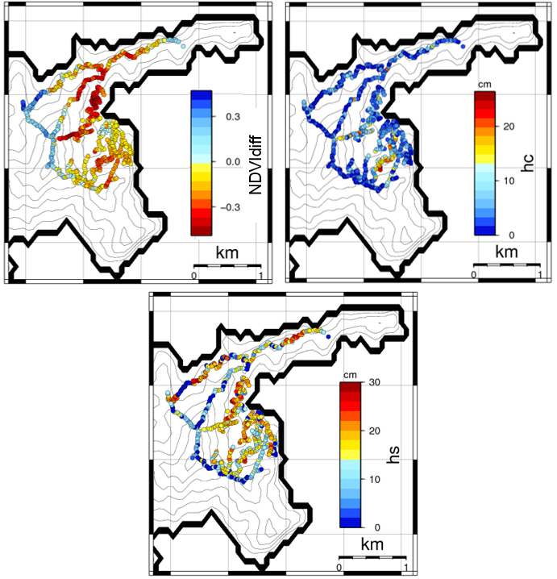

Fig. 2 Distribution of ${NDVI}_{diff}$, $h_{c}$ and $h_{s}$

The results indicate ${NDVI}_{diff}$ and $h_{s}$ can show more variation of fire severity than $h_{c}$. However, ${NDVI}_{diff}$ has a slight stronger relationship with $h_{c}$ (R = 0.29) than $h_{s}$ (R = 0.27) as shown in Fig. 3a and 3b.

Fig. 3a
Fig. 3(b)

Fig. 3a and 3b Correlation between ${NDVI}_{diff}$, $h_{c}$ and $h_{s}$ respectively
This suggests using direct value of $h_{c}$ and $h_{s}$ would not be a good indicator for fire severity as it may represent only the height of fire but by taking into account the $h_{c}$ and $h_{s}$ in relation to its total stem-bark height and crown height respectively, it could be a better representative of fire severity.

5. Conclusions
All three observation indicates variation of fire severity with ${NDVI}_{diff}$and $h_{s}$ exhibiting the most variations. Moreover, results indicate using rate of $h_{c}$ and $h_{s}$ based on its overall stem-bark height and crown height could offer a better estimation of fire severity. These results open new prospects for estimating the fire severity in the 2017 Kamaishi forest fire more definite.

6. Acknowledgements
We wish to thank Nohmura Foundation for Membrane Structure’s Technology for their generous financial assistance.

References
- Benavides-Solorio JDD, MacDonald LH: Measurement and prediction of post-fire erosion at the hillslope scale, Colorado Front Range. International Journal of Wildland Fire 14(4), 457–474, 2005.
- Kasischke ES, French NHF: Locating and estimating the areal extent of wildfires in alaskan boreal forests using multiple-season AVHRR NDVI composite data. Remote Sensing of Environment 51(2), 263–275, 1995.
- Keeley JE: Fire intensity, fire severity and burn severity: A brief review and suggested usage. International Journal of Wildland Fire 18(1), 116–126, 2009.
- Silins U, Stone M, Emelko MB, Bladon KD: Sediment production following severe wildfire and post-fire salvage logging in the Rocky Mountain headwaters of the Oldman River Basin, Alberta. Catena 79(3), 189–197, 2009.
- Statistic Bureau Japan: Japan Statistical Yearbook 2018
- Touge Y, Emang GP, Kazama S, Takahashi Y, Sasaki K: Introduction of the Tohoku Forest Fires on May 2017; case in Kamaishi city of Iwate Prefecture and Kurihara city of Miyagi Prefecture, 自然災害科学 J. JSNDS 36(4), 361–370, 2018

